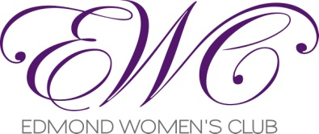

--------------- 2016 GRANT RECIPIENTS ---------------

All Things Baby
Alzheimer’s Association
Blue Star Mothers of America
Coffee Creek Riding Stables
D-DENT
Edmond Community Chorale
Edmond Mobile Meals
Fine Arts Institute of Edmond
Free to Live
Hope Center of Edmond
Jim Riley Outreach, Inc.
U R Special Ministries
UCO Foundation for the Arts
WINGS

